Visual Enhancement Technique for Underwater Images

INDEX

I. INTRODUCTION
1.1 TRADITIONAL TECHNIQUES FOR IMAGE ENHANCEMENT
1.5 DIGITAL IMAGE PROCESSING:
1.6 HISTORY:
1.7 IMAGE SAMPLING AND QUANTISATION:
1.8 DIFFERENT TECHNIQUES FOR UNDERWATER IMAGE ENHANCEMENT
II. LITERATURE SURVEY
III. RELATED WORK
Fig.3.1 Underwater imaging Model
IV. PROPOSED SYSTEM
V. RESULTS
VI. CONCLUSIONS
REFERENCES
Appendix: MATLAB

LIST OF FIGURE

Fig.1. Two different gray levels look same
Fig.2. (a) Raw image (b) Enhanced image
Fig.3. Histograms of an image before and after histogram equalization
Fig.4. (a) Raw image (b) Enhanced image
Figure 5: Water Surface Effects [1]
Fig 1.1 : Degraded and enhanced underwater image
Fig 1.2 Continuous Image
Fig.3.2 Input Image for White Balancing
Fig.3.3 white balanced image by gray world
Fig.4.1. Block Diagram of White Balanced BEMD
Fig 5.1.Input Raw image
Fig.5.2. Grayscale Image
Fig.5.3.White Balanced Image
Fig.5.4. Image after BEMD
Fig. 5.5 Proposed Method : Decomposition Levels and Enhanced Image

LIST OF TABLE
Table:1 Comparison of Histogram Equalization and BEMD techniques

Abstract
In the recent days, wide range of research has been carried out on visual enhancement of under images in submarine and military operations to discover submerged structural designing and sea floor exploration. But, diving in the deep ocean for a long time has increased the difficulties for analysis of underwater images. Further, other factors such as scattering resulting from presence of particles inside the water and blurring effects reduce the quality of images being captured by underwater optic camera. There are several algorithms have been introduced to improve the visual quality of deep water images. Therefore, in this project, a novel algorithm based on bidirectional Empirical Mode Decomposition (BEMD) to enhance the visual quality of the underwater images will be implemented and comparison of data with conventional enhancement technique will be illustrated. The implementation will be done using MATLAB software.
Index Terms— Visual enhancement, Image Processing, Scattering effects, Illumination conditions, BEMD

I. INTRODUCTION
The earth is associate aquatic planet and the maximum amount as eightieth of its surface is roofed by water. Moreover, there is a strong interest in knowing what lies in underwater. Present days, an image of deep waters has a scope to large investigation to explore the underwater for sea floor expedition and navigation. Enthusiasm of underwater imaging includes the inspection of plants, seabed exploration, the search for wrecks up and to the exploration of natural resources. There were several issues faced by the human in the underwater, if he dives deep into the ocean and stay there for a long time to perform experimentation. [1]. Due to the above reasons, unmanned remote vehicles are used to sea floor exploration.
A. Historical Development
Underwater image quality improvement approaches present a path to magnify the object recognition in underwater surrounding. A heap of research started for the upgradation of image visual quality, but a little amount of work has been carried out in this area. In the deep waters, image quality is degrades due to poor illumination conditions and the light properties differ in water compared to air.[2]. There were several parameters which decreases the quality of an image in underground waters. So in order to remove all these effects there are several techniques has been implemented and practiced.
B. Need for Pre process
Initially processing is necessary for deep water images due to their poor quality during acquisition. Necessity for preprocessing of deep water images
[1] are discussed below:
(i) Quality of images taken from deep water is deteriorated due to light ray attributes like scattering and absorption of light.
(ii) Specificity of surroundings such as lighting inequalities, water torridness, and blue complexion is more or less influential when vehicles move.
(iii) Video or image captured from deep waters like unknown rigid scene, and the depth of the scene and low light sensitivity due to Marine snow etc.
1.1 TRADITIONAL TECHNIQUES FOR IMAGE ENHANCEMENT
There are several techniques which are used very frequently for processing the image to improve the visual quality. Some of them are as follows:
(i) Contrast Stretching
(ii) Adaptive Histogram Equalization
A. Contrast stretching
The contrast stretching is a method to transform high intense region of image into more brighter and less intense region into more darker by using a predefined transformation function T(r) [2]. Generally, the underwater images will have less grey values. There are 256 grey values. ‘0’ indicates black and ‘255’ indicates white. In this method the current grey value of the image is stretched towards 255 i.e., from black to white, pixel by pixel. That means the contrast of the image is stretched, so that the quality of the image is improved for better vision.
For example:
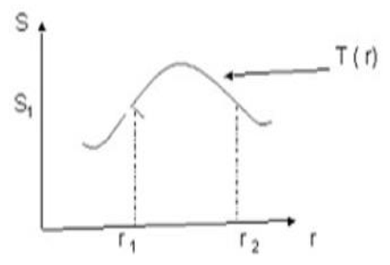
Fig.1. Two different gray levels look same
Here two different thresholds are considered for the entire image and the values between them are stretched to the maximum extent, so that the contrast increases. And more over by this method the entire global image contrast is enhanced.
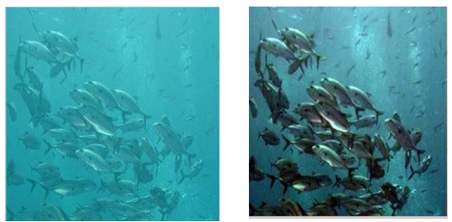
Fig.2. (a) Raw image (b) Enhanced image
But the disadvantage here is that the transformation function is not unique. Depending on the application the suitable transformation function is chosen.
B. Adaptive histogram equalization
Adaptive histogram equalization is a PC based image processing technique which is used to improve the quality of image properties like contrast. It is similar to contrast stretching method but with a slight difference. It computes several intensities of specific gray value, each corresponding to a distinct portion of an image, and with the help of them intensities are rearranged by applying a suitable transformation function. For example, a simple transformation function such as each pixel transformed based on the histogram of a square surrounding the pixel [3]. Existing values will be mapped to new values keeping actual number of intensities in the resulting image equal or less than the original number of intensities. The transformation function applied on the histogram is proportional to the cumulative distributive function (CDF) of pixel values in the neighborhoods. Therefore it suits for enhancing the local details and enhancing the edge information of each region of an image.
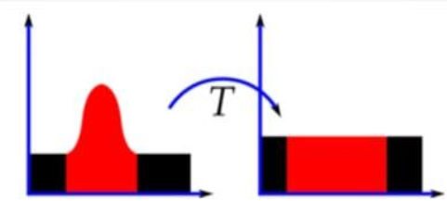
Fig.3. Histograms of an image before and after histogram equalization
Histogram equalization is a technique for changing the overall pixel intensities based on transformation function and contrast of an image. Histogram equalization is an effective technique which will benefit for the images with extreme contrast values. The limitation of this technique highlights the unwanted noise present in the background of an image and lead to loss in the information signal. It results in undesired effects in the resultant images [4].
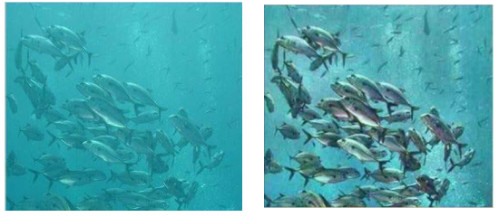
Fig.4. (a) Raw image (b) Enhanced image
Here the noise in relatively homogeneous regions of the image are amplified which results in poor SNR. And also only the local objects of the image are enhanced and the background is left unenhanced.
An image processing is a technique in which the data from an image are digitized in order to create an enhanced image that can be stored for future references study and human observer, Underwater imaging is quite a challenging in the area of photography. The importance of underwater activities to scientists for discovering, recognizing underwater imaging brings new challenges and enforce significant problems due to light absorption and diffusion effects of the light [2][3], This is because the images tend to become bluish as they go down deeper into the ocean to take photos, Coastal Malaysia is an attraction for scuba divers from around the world. Destruction of marine habitats caused by inexperienced divers, earth natural disaster unwittingly crash into corals that took years to grow as these novices have to yet to master techniques for maintaining buoyancy [4]. Before the habitat lost its shapes and actual structure, there is a need to preserve at least the images. This study will only focus on two techniques; the auto level adjustment and manual adjustment to enhance the underwater habitat images by using Adobe Photoshop. These images are taken by using a low end ordinary digital camera. The objective of this paper is to identify which technique is more significant in terms of color correction. The ultimate aim is to answer the research question that is "To what extent does the technique used can be corrected due to the depth of the surface's underwater habitat?"
There are a few problems occur in underwater images such as limited range visibility, low contrast, non uniform lighting, blurring, bright artefacts, color diminished and noise[4] [5][6]. [n the study of underwater images, it is found that those images are blurred due to light absorption and inherent structure of the sea. Due to the respective light reflection, Church, et. al. [I] explains that the reflection of light varies and it depends on the structure of the sea.
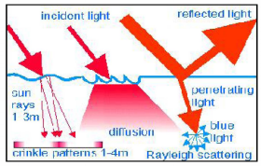
Figure 1: Water Surface Effects [1]
Figure 1 shows that water can bend the light either to create crinkle patterns or to diffuse the light. Anthoni [1] views that the reflected light is either polarized horizontally or entered the water vertically. When rays of light enter the water vertically it somehow makes the objects less shining and the images turn bluish [7]. Due to the problems mentioned above, it is significant to have a technique to improve the visualization of those images.
In the area of research and development, underwater imaging is a major field. In a lowered climate, there are several remarkable focal points such as sparkling scenes, marine creatures, and rare wrecks. Scattering and light maintenance are major factors in the poor separation and visibility of lowered videos. Ingestion significantly reduces gentle strength, and it is dependent on a variety of additional contaminants, such as pungency and turbidity of water, suspended waste, and so on Due to anomalies in the unfurl medium, flotsam and jetsam, and other influences, light dissipating causes the pillar to be diverted from its original route.
The foggy appearance, poor isolation, and obfuscation of shadings. Because of a hazy picture caught in lowered a few results of lower medium Methods for the suspended particles in lowered current regarding these forces. Light recurses at various stages of water. Longer frequencies are ingested first in water, and more pronounced small recurrences appear at a radius. The importance of water is inextricably linked to the concealment of information.
The alien takeover the importance of the water and recurrence determine the meaning of the tones. The absence of concealing in lowered photographs occurs in a comparable solicitation when they appear in the concealing assortment, resulting in a fairly blue tone in lowered photographs. The redesigned photograph as a result of the planned technique is seen in Fig-1.1
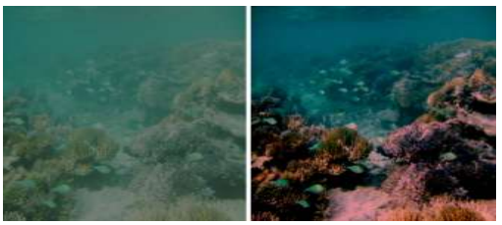
Fig 1.1: Degraded and enhanced underwater image
1.5 DIGITAL IMAGE PROCESSING:
The use of figures to complete picture preparation of modernized pictures is known as advanced picture overseeing. Progressed image management, as a subcategory or topic in electronic sign planning, has a range of advantages over plain photo management. It enables a much larger range of figures to be added to the insights and can be free of annoyances such as the Over the course of overseeing, the upheaval and sign mutilation also improved. Since pictures are shown more prominently than estimates (possibly even more so), electronic photo management is more certainly classified as multidimensional structures. With the fast PCs and sign processors that became available in the 2000s, advanced image preparation has been the most serious since it isn't just the most adaptable technique, but also the least widely tested, it is a noteworthy form of image management and by using and enormous. In 1994, the Electronic Image Oversight Development for Logical Packages was inducted into the Space Foundation Space Technology Hall of Fame.
In the broadest context, picture taking care of refers to the tending to and stalling of realities that are in good working order. Image preparation is the management of numerical realities found in a jumbled snapshot to improve the apparent appearance, which is more notable marginally. Obscured photographs can be advanced, therapeutic images explained, and satellite images modified using photo editing tools.
Picture concerned with programming can also convert numeric data into visible images that can be modified, revamped, filtered, or invigorated to show relations that were previously not obvious. Inquisitively, picture evaluation entails taking measurements from pre-recorded demos as tests, and can then be used to test and develop new products shifted. Despite the fact that fundamental eight-cycle numbers or vectors with eight-digit numbers are the most commonly used types of pixel regards, some picture plans keep a range of high-value types, such as 32-bit stamped whole numbers or characteristics. Such qualities are extremely useful in picture dealing with because they allow for preparation to be completed on a picture where the pixel references are not just 8-cycle whole numbers If this method is used, it is generally necessary to create a concealing guide that connects explicit pixel extents to explicit seen colors.
1.6 HISTORY:
During the 1960s, at the Jet Propulsion Laboratory, Massachusetts Institute of Technology, Bell Laboratories, University of Maryland, and other assessment working environments, a large portion of the procedures of general photograph planning, or programmed picture adapting to as it was sometimes called, were created, with programming to satellite imagery, line photo standards, and other assessment working environments Clinical photography, videophone, singular affirmation, and photograph overhaul are all examples of change. With the preparing equipment available at the time, the speed of preparation was completely out of control.
That changed in the 1970s, as advanced photograph supervision grew as less costly PCs and submitted hardware became available. Photographs will be taken care of by then For a few dedicated subjects, such as entertainment, proposals shift on a daily basis. With the advancement of typically beneficial PCs, they began to focus on control over the interaction of submitted hardware for all but the most serious basic and PC fundamental obligations.
1.7 IMAGE SAMPLING AND QUANTISATION:
To create a high-resolution image, we must convert the steady described data into an electronic format. This is made up of cycles:
1) Sample size
2) Quantitative analysis
The critical thinking process that goes into measuring and quantification is printed. In terms of the x-and y-organizes, a photograph is most certainly accurate, as well a plentiful supply To turn it into a cutting-edge framework, we must assess its capacity in terms of directions and sufficiency. Looking at is the method of digitizing the get ready attributes. Quantization is the method of digitizing the excess of something.
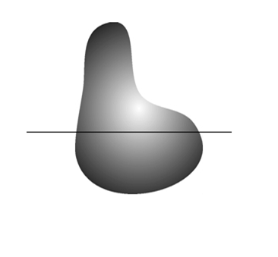
Fig 1.2 Continuous Image.
The one-dimensional skill is a line component plot of adequacy (dim level) assessments of the constant frame. Because of the photographic commotion, the subjective varieties arise. We use comparatively isolated models close to line AB to measure this cap. Each example's location is indicated by a vertical tick mark in the figure's base piece. The models appear as simple white squares overlaid on the power.
The submerged state of various phenomenal attractions like marine animals and fishes, astounding scene, and cryptic wrecks. A noteworthy wellspring of submerged photography and submerged imaging, etc are energy for different pieces of advancement, for example audit of submerged establishments and connections, control of submerged vehicles, acknowledgment of man-made articles, ocean life science research and pale history.
For the image update technique are three unmistakable sorts. For instance, point taking care of, spatial isolating and picture concealing. Undertaking of point getting ready are three unmistakable technique like distinction improvement, histogram showing, picture averaging. The spatial isolating is four one of a kind methodologies, for instance, straight channels, non-direct channels, edge distinguishing proof, and zooming. In addition, the image concealing there are two one of a kind systems like pseudo concealing, fake concealing.
The separation redesign is an unavoidable term in radiology and can be used in three unmistakable habits. At first, it may insinuate systems for exaggerating the perceptible qualification between close by structures on channel by managing contrast experts. The histogram of an image addresses the general repeat of occasion of the distinctive diminish levels in the image. The histogram showing frameworks change an image all around so its histogram has a perfect shape. Picture averaging is the system are modernized picture taking care of that is a normally used to overhaul video pictures that have been spoiled by self-assertive disturbance.
Direct channels process time varying info signs to produces yield signals and used to the subject necessity of linearity. In this result showed up from system framed propelled figuring assembled having an immediate response. The yield is definitely not an immediate limit it's a data because of this non straight channel. The channels of yield signals R similarly as S for the data signals r and s are freely. The data is a straight mix αr+βs yet doesn't yield reliably αR+βS. Edge distinguishing proof is an image getting ready strategy finding the constraints of an article inside picture. In edge revelation is used for picture division data extraction like a PC vision, machine vision and picture getting ready, etc.
To the dim characteristics subject to a specific models used of a selecting different tint these tones are called pseudo concealing. To monochrome pictures from the strategy related with genuine nature pictures is used to separate of allotting tints. In implies a social occasion of concealing rendering strategies are used to show pictures in concealing is known as counterfeit concealing or pseudo concealing. There are two sorts of electromagnetic range for instance clear part or non-observable part.
Image enhancement is the mechanism to process the input image to make it more appropriate and clearly visible for the required application. Image enhancement improves the information content of the image and alters the visual impact of the image on the observer. Image enhancement intensifies the features of images. It accentuates the image features like edges, contrast to build display of photographs more useful for examination and study. Qualitative objective approach is used in enhancing images to construct a visually impressive picture. Image enhancement includes many operations such as contrast stretching, noise clipping, pseudo coloring, noise filtering etc to improve the view of images.
Active range of the chosen features of images is amplified by enhancement so that they can be detected simply. The existing research shows that underwater images bears poor quality because of nature of light. When light enters the water it got refracted , absorbed and scattered as water is denser medium then air , so the amount of light drops when it enters from air to water and got scattered in different directions. Scattering causes the blurring of light and reduces the color contrast. These effects of water on underwater images are only not due the nature water but also because of the organisms and other material present in the water. Light containing different wavelengths of blue, green and red colors will make a way into water to a changeable degree [2]. Figure 1 shows the picture about the light absorbed by water. With every 10m augmentation in depth the brightness of sunlight is going to fall by half. Almost all red colored light is decrease to 50% from the surface but blue continues to great deep in the ocean because blue color have the shortest wavelength and so it travels the longest distance in the water. That is why most of the underwater images are subjected to blue and green color.
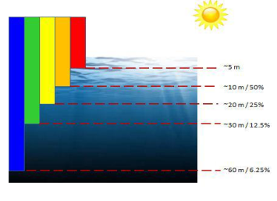
Fig 1
1.8 DIFFERENT TECHNIQUES FOR UNDERWATER IMAGE ENHANCEMENT
1. Contrast stretching- Contrast stretching is a straightforward image enhancement method that is used to improve, enhance the image contrast by `stretching' the series of intensity values. A measure of image’s dynamic range or the "broaden" of image’s histogram is the contrast of an image. Whole range of intensity values present within the image, or in a easier way, the minimum pixel value subtracted from the maximum pixel value is called dynamic range of image. It differs from the more complicated histogram equalization in a way that it can only concern a linear scaling function to the image pixel values.
2. Empirical Mode Decomposition- EMD is a versatile and based on the local moment period function of the figures[9]. So, it is suitable to help nonlinear along with non-stationary data so that it is an incredibly adept opportunity for real-life software. The EMD method is exceptionally direct, and the fundamental procedure is to carry out sifter operations on the new data arrangements until the final data series are stationary, and subsequently disintegrate the whole signal into many Intrinsic Mode Functions (IMFs) and a residue. EMD is connected to the Red, Green, Blue channels independently. The original image is break up into several intrinsic mode functions by EMD process and a final residue.
3. Homomorphism filtering
The homomorphic filtering is utilized to fix non-uniform lighting to reinforce contrast from the impression. This is a frequency filtering technique. It is the most utilized system on the grounds that it redresses non-uniform lighting and sharpens the picture.
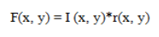
Where F(x, y) is the function of image detected by device, I(x, y) the illumination function and r(x, y) the reflectance function[12]. By multiplying these components filter can reduce the non uniform illumination present in the image.
4. Anisotropic filtering Anisotropic filtering disentangles picture components to enhance picture division. This channel smoothes the picture in homogeneous range however conserve edges and upgrades them. It is utilized to smooth compositions and diminishes relics by erasing little edges enhanced by homomorphic filtering.
5. Wavelet denoising by average filter Wavelet denoising is used to stifle the noise i.e the Gaussian noise are normally present in the camera pictures and other kind of instrument pictures. While moving the pictures Gaussian noise can be included. This wavelet denoising gives great results contrasted with other denoising routines because, unlike other methods, it does not assume that the coefficients are independent. Undoubtedly wavelet coefficients in normal pictures have enormous conditions. Besides the reckoning time is short.
6. Red channel method In this method, colors associated to short wavelengths are recovered, as expected for underwater images, leading to a recovery of the lost contrast[10]. The first thing in this method to estimate is the color of the water. Pick a pixel that lies at the maximum depth with respect to the camera. It is assumed that degradation of image depend upon location of pixel. After estimating the water light transmission of the scene is estimated. Then Color correction is done.
7. Histogram equalization Histogram equalization is a method for modifying image intensities and contrast of image in image processing using the image's histogram. Histogram equalization is helpful in pictures with backgrounds and frontal areas that are both bright or both dim. This is a simple and straightforward technique. But it has a disadvantage also that is it also amplifies the background noise present in the image and lead to decrease in the useful signal. So it produces unrealistic effects in the output images. The basic idea lying behind this method is mapping the gray levels depending upon the probability distribution of the input gray levels.
8. Contrast Limited Adaptive Histogram Equalization (CLAHE) It is generalization of adaptive histogram equalization. With this technique the image is broken up into tiles. The gray scale is calculated for each of these tiles, based upon its histogram and transform function, which is derived from the interpolation between the manipulated histograms of the neighboring sub-regions. The transformation function is relative to the cumulative distribution function (CDF) of pixel values in the area. CLAHE contrasts from AHE in contrast limiting. CLAHE limits the noise enhancement by cut-out the histogram at a client characterized worth.
A. CLAHE on RGB color model RGB color is an additive color model which depicts hues regarding the measure of red (R), green (G) and blue (B) present. It depicts what sort of light needs to be transmitted to create a given hues present in the image. CLAHE can be applicable to all the three parts ie. red, green and blue separately. The effect of full-color RGB can be acquired by combining the individual components of model.
B. CLAHE on HSV color model HSV color model defines colors in terms of the Hue (H), Saturation (S), and Value (V). HSV color model is cylindrical coordinate illustration of points in an RGB color model. Hue is the characteristic of a visual sensation as indicated by which a territory seems to be related to one of the color seen. The hue and saturation level don't have any kind of effect when value is at max or min intensity level. CLAHE is applied on V and S components[2].
9. Integrated color model
The integrated color model is principally established on color harmonizing by contrast improvement is RGB color space and color adjustment in HSI model[14]. In integrated color model first step is to diminish the color cast by the equalization of all the color values present. In the second step an improvement is applied to the contrast amendment to broaden the histogram values of the red color. Second step is again done for green and blue colors. In the last step of the model, the saturation and intensity components of the HSI color model is applicable for contrast adjustment to enhance the true color and for dealing with the issue of uneven illumination.

II. LITERATURE SURVEY
1] Padmavathi, G., et al. "Comparison of filters used for underwater image preprocessing." International Journal of Computer Science and Network Security10.1 (2010): 58-65.
Underwater image pre-processing is absolutely necessary due to the quality of images captured under water. Basically, under water images suffer from quality degradation due to transmission of limited range of light, low contrast and blurred image due to quality of light and diminishing color. When an underwater image is captured, pre-processing is necessarily done to correct and adjust the image for further study and processing. Different filtering techniques are available in the literature for pre-processing of under water images. The filters used normally improve the image quality, suppress the noise, preserves the edges in an image, enhance and smoothen the image. Therefore an attempt has been made to compare and evaluate the performance of three famous filters namely, homomorphic filter, anisotropic diffusion and wavelet denoising by average filter used for under water image pre-processing. Out of the three filters, wavelet denoising by average filter gives desirable results in terms of Mean Square Error and Peak Signal to Noise Ratio. However the elapsed time of the three filters is also studied to identify the suitable filters that process the image quickly by preserving the image quality.
The three edge preserving filters taken for study are homomorphic filter, anisotropic diffusion filter, wavelet denoising by average filter. Underwater image suffers from transmission properties of water, the transmission of limited range of light, disturbance of lightening, low contrast and blurring of image, diminishing color during capturing of image. Recently pre-processing is done only for correcting the non-uniform lights or color and intensity adjustment. The performances of the filters are compared and analyze by the PSNR and MSE vales for underwater images. The speckle reduction by anisotropic filter improves the image quality, suppressed the noise, preserves the edges in an image, enhance and smoothen the image. The mean square error value which must be low for an image and peak signal to noise ratio which must be high in an image. Though the wavelet filter shows high and low for PSNR and MSE. Moreover the elapsed time of the three filters is also studied to identify the suitable filters that process the operation quickly by preserving the image quality. The SRAD filter perform its operation in less number of seconds when compare to other filters.

[2] Yan-TsungPeng and Pamela C, "Lowered Image Restoration Based on Image Blurriness and Light Absorption," IEEE trades on photo preparing, vol. 26, no. Four, April 2017.
Image fogginess and light digestion were used to propose an exact significance assessment technique for restoring lowered images. It will be used to enhance and repair the deteriorated underwater picture in general within the image affiliation form. Since scene importance isn't often measured by concealing channels, it's possible to recover lowered photographs correctly. More notable extraordinary BL and importance appraisal are included in the recommended method. First and foremost, BL has a low-resolution shot of hazy districts. The meaning chart and the TMs are then applied to recover scene brightness in light of the BL. The suggested technique's flowchart as seen in Figure 2.1.

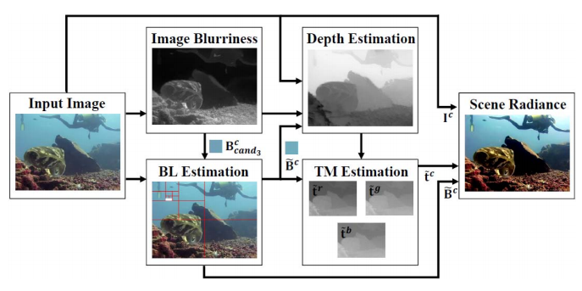
Fig 2.1: Flowchart of our proposed method
The importance of darkness is immense. Picture fogginess isn't necessarily used to assess significance; picture murkiness and light repairs are also taken into consideration. Foggy BL is made up of contender BLs obtained from foggy places. After that, the more drastic whole-image retrieval techniques are used. By considering BL, significance evaluation is based on Fake lights can be addressed using light osmosis. Water absorbs all of the most notable light so it passes a larger distance within the water. Counterfeit illumination is often used to provide enough illumination for taking low-light photographs and accounts.
A top notch frontal area is outlined by fake lights in a lowered image. Frontal region items are used to mull through the light that comes from a phony lighting apparatus' supply. It flies a shorter distance within the water and is less confined and dispersed. In comparison to premise pixels, dishonestly illuminated impeccable nearer see pixels are fewer ventured forward using a recovery technique. In the case that the BL of a lowered picture involves slight fake illumination, Changing with the significance map gathered with the aid of the blood red channel guide will see those stunning pixels as being near and not over-take care of their concealment at this stage.
When BL is breathtaking, the pink light from the institution pixels can dim more than that from the frontal district pixels, which can be successfully interpreted as scene the meaning The suggested technique has the potential to enhance reconstructing and progression by bringing in approximately different lowered concealing tones and light conditions that are different from most lowered photo recovery procedures.
[4] Amjad Khan S.S. A. Ali, A. S. Malik, A. Anwer and F. Meriaudeau, "Lowered Image Enhancement via Wavelet Based Fusion," 2016 IEEE International Conference on Underwater System Technology: Theory and Applications (USYS), Penang, 2016, pp. 83 88.
A wavelet-based totally hybrid approaches to boost hazy, low-resolution images while keeping an eye out for low separation and hiding replacement problems. The dinky degraded lowered image is copied into two characterizations right away. These activities are carried out in a way that is linked to Improve picture distinction to let it stand out. The wavelet-based blend degree necessitates the movement of redundant and infrequent pass channel banks.
Separation bound adaptable histogram balance is an example of a flexible histogram balance. It is embraced in order to improve the distinction and essence of the separation reduced photograph by removing the useless area from the histogram The normalization of the histogram and the scale of the local regions within the pixel space represent the decreasing breaking element. The cut district isn't often discarded, but it is often adjusted through all histogram canisters. To increase the distinction of all hues available in the photograph, the separation limited adaptable histogram leveling is extended to all concealing channels. Figure 2.3 illustrates
the flowchart of the suggested strategy.
Hazy Image
Color Correction

Decomposition
Into Wavelet
Coefficients
Decomposition
Into Wavelet
Coefficients

Color
Enhancement
Fusion of
Wavelet
Coefficient
Wavelet
Based Inverse
Composition
Enhanced
Image

Fig 2.3: Flowchart of proposed method
To exclude unwanted low and inordinate frequencies blessing from the picture and improve the overall cycle quality, a set of low detour and high pass channel banks is used. Here, two levels of crumbling are included. Stage one has several levels: the first is obtained by applying the low detour and high skip channels close by down-inspecting on the data's hints; the second is obtained by applying the low detour and high skip channels close by down-inspecting on the data's hints; and the third is obtained by applying the low detour and high skip channels close by down-inspecting photograph. Approximations and complexities of level are made.
The level coefficients of the fragments are separated and down-tried at this stage. The rotted vague picture from level one would become the detail photo at the second level of degradation. To scale down coefficients, the interchange is repeated. Using a similar technique, each detail picture was crumbled into wavelet coefficients. The two weakenings are consolidated during sustained shutting by using coefficients of most severe over the top characteristics.
[3] Hung-Yu Yang et al., P. Chen, C. Huang, Y. Zhuang and Y. Shiau, "Low Complexity Underwater Image Enhancement Based on Dark Channel Prior," 2011 Second International Conference on Innovations in Bio-breathed life into Computing and Applications, Shenzhan, 2011, pp. 17-20.
Low-stacking and powerfully lowered photograph enhancement strategy proposed in response to incompetent channel before. Two law designs are used in this technique. In the main location, air light evaluation is performed by calculating faint channel prior and importance map with the aid of concentration a platform. Second, an independent concealing correction technique is used to increase the item's concealing contrast to further improve the obvious concept of the lowered image. The suggested approach's stream description as shown.
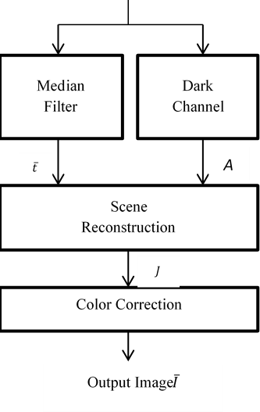
Fig -2.4: Flow diagram of proposed method
The faint channel before is used to measure natural light. The low powers in the lack of meaning channel are largely due to factors such as shadows, delightful posts, faint artifacts, and so on. The delicate tangling figuring is used in the haziness channel prior approach to flush out the square effect of the transmission and replicate an unrivaled photo. It necessitates major enrolling consequences as well as a few cycles to smooth and improve delivery. To solve the problem, the center channel is used for the clearly visible picture in order to achieve smooth transmission.
In the lack of definition channel, the top most prominent pixels are selected, and among these pixels; Because of the air light, the pixels with the most enhanced forces are selected. A helpful concealing adjustment technique is added to the aspect. Since lowered photos mask needless blue when separating and final colors, the blue tone can be used to highlight the unpracticed and red tones can be used to alter the picture. To gather a concealing changed picture, the most broadened blue tone is prepared as a target recommend, and the abundance concealing channels are settled with a multiplier.
[4] John Y. Chiang et al, "Lowered Image Enhancement through Wavelength Compensation and Dehazing," in IEEE Transactions on Image Processing, vol. 21, no. 4, pp. 1756-1769, April 2012.
Proposed a system for recovering lowered photographs that combines a dehazing statistic and recurrence compensation. The distance between the digicam and the thing was measured ahead of time using faint divert, and the mist effects were eliminated using the dehazing computation. At that time, the scene meaning has been classified based on the energy extents of each occurrence in the scene The photograph's foreground sun. The volume of aggregate suspended particles and salt varies depending on the time, zone, and season. To restore the picture, change compensation is similarly organized with the guide of the degree of decreasing each recurrence. In a hazy climate, shadowiness increases with time.
After assessing the It is possible to approximate the distance between the article within the scene and the frame due to the centralization of shadiness in a single photograph. The figure that uses a faint channel prior relies on squares, resulting in a significantly less explicit significance map. Picture tangling is often done to reorganize the importance guide, and it necessitates the dedication of a starter The key photograph and the meaning chart were divided. The relation between the mean tone and the covariance of a neighborhood the image is used to remember items. The association of papers is then used to cure the major isolated importance map.
The measurement of the space between the things and the water floor is then carried out to solve the problem Methods for water significance began concealing solid. It is expected that significance estimation at each point within the image would result in relating energy compensation at the various depths. Counterfeit light sources are often more grounded at some point during the picture-taking process in order to avoid powerless light inconveniences.
[5] Chongyi Li et al, J. Guo, R. Cong, Y. Hurt and B. Wang, "Lowered Image Enhancement via Dehazing with Minimum Information Loss and Histogram Distribution Prior," in IEEE Transactions on Image Processing, vol. 25, no. 12, pp. 5664-5677, Dec. 2016.
Proposed a comprehensive approach for enhancing single lowered images that could produce orders of overhauled yield. The suggested technique consists of two main components: reduced image dehazing and reduced photo examination progression. A skilled dehazing computation that relies on a foundation Wide and optical places of lowered imaging are used in the measurements. It will recover the detectable consistency, concealment, and distinctive appearance of lowered previews that have been destroyed. A persuasive and clear differentiation improvement count is also suggested, based on a type of histogram scattering prior that improves the brightness and separation of a lowered photo. There are classifications for mature images. It is fair to look nice in the first form, which has an ordinary appearance and an usually overt tone. The inferior with excessive brightness and contrast could be used to obscure more notable complexities while eliminating more influential large perspectives. What are the commands of Photographs that have been revised can be used for a variety of programs. The overall premise light assessment, medium transmitting map evaluation, and adaptable transparency map analysis are used to create a lower photo dehazing estimate.
1) A gentle review of the global premise It happens on a daily basis In a lowered photograph, it was voted as the most majestic sound. For assessing global institution sun, a separate leveled expanding approach focused on quad tree growth is used. With the aid of the faint channel prior process, the effects of suspended particles are removed. In the end, The ultimate premise light is ordered with the aid of the gentle going in the water homes within the wake of removing the annoyances of unfathomable objects.
2) Appraisal of a medium transmission map. The advanced picture is dependent on the medium transmission map's reliability. An information pixel incentive is mapped to a yield consider by a medium transmitting work. To reduce measurement loss, an optimal medium transmission map is chosen. The medium transmitting manual of the most degraded channel is classified to restrict data loss. The pink channel's medium transmission manual is being evaluated For restoring a lowered image, this is a prominent realistic choice.
3) Assessment of adaptive transparency maps: Unnecessarily faint or exorbitantly top notch districts can also appear as a result of underwater image dehazing computation. It is used for higher visual nature of lowered image to prevent this. Flexible transparency manuals will adjust regions that are too small or too large. At the perceptions of histogram scattering of standard scene images, lower image contrast refines. The histogram motions of well-known scene pictures are much more steady and popular. This animation shows how to swap the histogram flows of lower-resolution images for better differentiation and brightness. Unpleasant histogram preparation is used to swap the histogram transports of photographs collected with decreased dehazing figuring.
[7] G. E. Guraksin, U. Kose and O. Deperlıoglu, "Lowered Image Enhancement Based on Contrast Adjustment through Differential Evolution Algorithm," 2016 International Symposium on Innovations in Intelligent Systems and Applications (INISTA), Sinaia, 2016, pp. 1-five.
Using differential enhancement figuring, I suggested a reduced picture progression. The lowered image has been separated into RGB concealing fragments from the start, and each section has been ventured forward. After the differentiation enhancement process, the red, green, and blue components are joined together to produce the shaded image. Differential improvement count is used to select the

separation limit when improving the varieties of each element. Finally, the lowered picture is sharpened by using unsharp hiding mainstream. A photograph's histogram is the level of tone repetition in the picture. Low separation images result from a lack of illumination apparatuses.
Separation widening may be used to improve the quality of these images. The main idea behind distinction stretching is to increase the effective range of the faint levels within the managing photo. Differential change count is a brilliant and simple people-based metric For resolving global advancement problems, use a stochastic journey strategy. The three statute chiefs used in differential improvement count are shift, half and half, and tendency. For each goal vector in the current population, an oddity vector is generated in the adjustment hobby.
Three discretionarily selected vectors with a change cap are used to construct the change vector. As a result of creating a monstrosity vector, it has a position with cross breed desire with the target human, forming a primer relationship. To update the association, a judgment collaboration is used after the mixing action. The alternative extraordinary counts reveal the devotion transaction on this computation.
[8] Sowmyashree M. S., Sukrita K. Bekal, R. Sneha, and N. Priyanka. "A Survey on the various underwater image enhancement techniques." International Journal of Engineering Science Invention, 2014.
The primary objective of underwater image enhancement is to recover the quality that has been degraded due to scatters and amalgamation within the underwater environment. These images suffer from strong absorption, low contrast, noise, and poor visibility. Thus to avoid aforementioned problems of the underwater images, enhancement is required. This paper discusses various image enhancement techniques like Histogram equalization, Adaptive Histogram Equalization(AHE), CLAHE, Histogram slicing, Contrast stretching, Dark Channel Prior, etc.
Today, underwater image processing has made a distinct identity in the field of research due to increasing demand for a good quality picture in many applications. Taking a good quality picture in the underwater environment is not an easy task, it requires some dedicated hardware. In the absence of the specialized hardware, we get degraded image, which we have to enhance. Enhancing an image means, to remake the digital picture so that the resultant image can be further be utilised for better display or investigation purpose. Image enhancement mainly deals with sharpening image features like boundaries, edges or contrasts and reduces the ringing artifacts. When we capture an image or video in an underwater environment, the quality of image/video degraded due to scatters and amalgamation.
These images suffer from strong absorption, low contrast, noise, and poor visibility. Thus these underwater images require enhancement for certain applications. In recent decay, the applications of underwater image processing have increased in various domains like mine detection, underwater microscopic detection, autonomous underwater vehicles, telecommunication cable terrain scanning, etc. Thus enhancement of an image is being potentially significant. In digital image processing, there are many image enhancement techniques are available for instance the Histogram equalization, white balancing, fusion-based method, dark channel prior, color correction, but these are not applicable to underwater image processing because these methods are not suitable for a physical model of underwater. Thus many researchers have proposed many different techniques for underwater image enhancement.
[9] Aysun Tas_yapı Celebi and Sarp Erturk. “Visual enhancement of underwater images using Empirical Mode Decomposition” Elsevier , 2011.
Most underwater vehicles are nowadays equipped with vision sensors. However, it is very likely that underwater images captured using optic cameras have poor visual quality due to lighting conditions in real-life applications. In such cases it is useful to apply image enhancement methods to increase visual quality of the images as well as enhance interpretability and visibility. In this paper, an Empirical Mode Decomposition (EMD) based underwater image enhancement algorithm is presented for this purpose. In the proposed approach, initially each spectral component of an underwater image is decomposed into Intrinsic Mode Functions (IMFs) using EMD. Then the enhanced image is constructed by combining the IMFs of spectral channels with different weights in order to obtain an enhanced image with increased visual quality. The weight estimation process is carried out automatically using a genetic algorithm that computes the weights of IMFs so as to optimize the sum of the entropy and average gradient of the reconstructed image. It is shown that the proposed approach provides superior results compared to conventional methods such as contrast stretching and histogram equalizing.
In recent years, there is an increasing interest in underwater remotely operated vehicles (ROV’s) and autonomous underwater vehicles (AUV) for submarine and military operations. These vehicles are typically equipped with optical sensors (cameras) to capture underwater images for short range applications. The main drawback of employing optical cameras in underwater applications is limited visibility that can be restricted to about twenty meters in clear water and less than a few meters in turbid and coastal waters (Arnold-Bos, Malkasse, & Kervern, 2005). The quality of images acquired under the sea can be poor because of specific propagation properties of light in water, so image enhancement is necessary to enable effective interpretation means for operators.
The most important reason of underwater image degradation is due to transmission properties of light in water, such as absorption (light disappears) and scattering (light changes direction). Another problem is related to depth. Due to the nature of underwater optics, red color disappears at the depth of about 3m and orange color starts diminishing a little further, while yellow color is lost at a depth of about 10 m and green goes off at further depths, so finally at 25 m only blue color remains, thus causing the image to typically appear bluish (Abril, Méndez, & Dudek 2005). The third problem is marine snow that resembles snowflakes suspended in the deep ocean. Marine snow can produce bright artifacts. As a result, underwater images have restricted visibility, non-uniform lighting, low-contrast, diminished colors and blurring of image features. Some of these effects are even observed when external lighting is used. Enhancement methods have been proposed in the literature to improve image quality, compensate attenuation effects, enhance contrast, adjust colors, suppress noise and blur, while preserving and possibly even enhancing edges.
[10] Adrian Galdran, David Pardo, Artzai Picón and Aitor Alvarez-Gila” Automatic Red-Channel underwater image restoration” Elsevier, 2014.
Underwater images typically exhibit color distortion and low contrast as a result of the exponential decay that light suffers as it travels. Moreover, colors associated to different wavelengths have different attenuation rates, being the red wavelength the one that attenuates the fastest. To restore underwater images, we propose a Red Channel method, where colors associated to short wavelengths are recovered, as expected for underwater images, leading to a recovery of the lost contrast. The Red Channel method can be interpreted as a variant of the Dark Channel method used for images degraded by the atmosphere when exposed to haze. Experimental results show that our technique handles gracefully artificially illuminated areas, and achieves a natural color correction and superior or equivalent visibility improvement when compared to other state-of-the-art methods.
The field of underwater imaging has drawn much attention over the last years. The possibility of improving underwater images by just using image processing techniques is very appealing due to the low cost of implementation when compared with more sophisticated techniques. These methodologies enjoy a wide range of applications, from marine biology and archaeology (1) to ecological research (2). The improvement of unmanned vehicles (ROV) navigation capabilities (3) is also a very important field of application. For example, underwater vehicle navigation can be guided through video mosaics (4).
Mosaicing requires a previous registration of different input images (5), and image processing techniques are usually implemented as a preprocessing step to improve the results. The problem of restoring images degraded by an underwater environment is challenging, in part because light traveling underwater suffers from two combined degradations, known as scattering and absorption.
The former consists on a change of direction of light after collision with particles, and the latter explains how particles absorb light. The main consequences of these degradation processes are a decrease in the visibility distance and a color distortion that depends on the wavelength of each light beam. The shorter wavelengths (green and blue colors), reach further depths in the scene than the rapidly vanishing longest ones (red), transferring to the final image a characteristic bluish greenish tone. Together with turbidity of the water, and the organic particles suspended on the medium, this yields a hard restoration problem, since overall performance of algorithms becomes highly dependent on environmental conditions. Often, an artificial light source is added to the imaging device to try to increment the visibility range in the scene, but this entails some disadvantages: the amount of power needed to illuminate underwater scenarios can be prohibitively expensive; moreover, illumination is not obtained in a global uniform way and a bright area in the center of the image tends to appear, as backscattering occurs from nearby particles causing visual disturbance.
III. RELATED WORK
These effects are governed by the suspended particles that lead to absorption and scattering of light during image formation process. The underwater medium is not friendly for imaging data and brings low contrast and fade color issues. As an important problem in image processing and computer vision, the restoration and enhancement of underwater image are necessary for numerous practical applications. Over the last few decades, underwater image restoration and enhancement have been attracting an increasing amount of research effort.
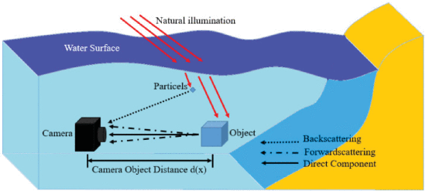
Fig.3.1 Underwater imaging Model
Color Constancy
Color constancy is a mechanism of detection of color independent of light source. The light source many introduce color casts in captured digital images To solve the color constancy problem a standard method is to estimate the color of the prevailing light and then, at the second stage, remove it. Once the color of light in individual channels is obtained the each color pixel is normalized by a scaling factor . Two of the most commonly used simple techniques for estimating the color of the light are the Grey-World and Max-RGB algorithms. These two methods will work well in practice if the average scene color is gray or the maximum is white.
Gray world assumption
The Gray World Assumption is a white balance method that assumes that your scene, on average, is a neutral gray. Gray-world assumption hold if we have a good distribution of colors in the scene. Assuming that we have a good distribution of colors in our scene,the average reflected color is assumed to be the color of the light. Therefore, we can estimate the illumination color cast by looking at the average color and comparing it to gray. Gray world algorithm produces an estimate of illumination by computing the mean of each channel of the image.
The Gray World Assumption is a white balance method that assumes that your scene, on average, is a neutral gray.
Imagine you are given this JPEG image, and your task is to correct the white balance:
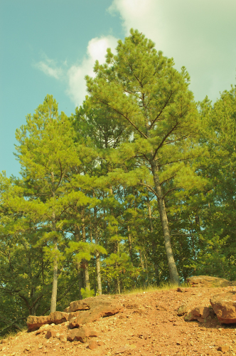
Fig.3.2 Input Image for White Balancing
This appears to have an overall yellowish-green color cast. Gray World assumes that all the colors in an image ought to average out to a neutral gray: for every blue there is a yellow, for every red there is a cyan, and for all greens there are magentas.
Remove the gray layer, and you have a white balanced image:
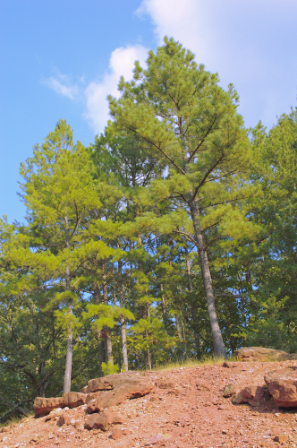
Fig.3.3 white balanced image by gray world

EMD
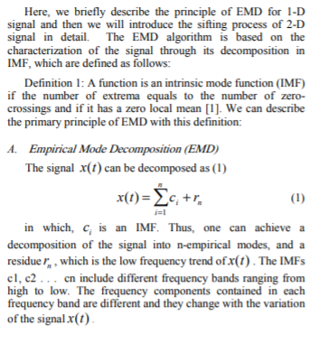
BEMD
Bidimensional empirical mode decomposition (BEMD) techniques decompose an image into several bidimensional intrinsic mode functions (BIMFs) and a bidimensional residue (BR). Although currently existing BEMD methods are proposed for gray level images, there has been no BEMD method for color image analysis.
Empirical mode decomposition (EMD) is a relatively new signal processing tool that was originally developed to analyze nonlinear and non-stationary one-dimensional (1D) signals [1]. Bidimensional empirical mode decomposition (BEMD) is a two-dimensional (2D) extension of the concept of EMD, which is a multi-resolution decomposition technique aimed mainly for image processing [2, 3, 4]. BEMD and its variants decompose an image into several bidimensional intrinsic mode functions (BIMFs) and a bidimensional residue (BR). BEMD requires finding local maxima and minima points (jointly known as local extrema points) and subsequent interpolation of those points to estimate the upper and lower envelope surfaces of the data. However, the application of surface interpolation causes various difficulties and/or problems in the process. Several modifications have been suggested in the literature to remove or reduce the difficulties of the BEMD methods by efficient surface interpolation and/or other processing, which is discussed in details in [5]. Still, surface interpolation based BEMD (SIBEMD) methods suffer from the problems of undesired end effects, impractically high computation time, and inappropriate BIMFs. These problems further limit the application of SIBEMD methods to real images of only low resolution/size.
Recently a novel approach of fast and adaptive BEMD (FABEMD) is proposed that replaces the interpolation step by a direct envelope estimation method [6, 7, 5], where, spatial domain sliding order-statistics filters (OSFs) are employed to get the running maxima and minima of the data, respectively. Application of a smoothing operation to the running maxima and minima results in the desired upper and lower envelopes, respectively. It has been shown that the FABEMD not only provides faster decomposition, but also provides BIMFs with relatively less distortion or other artifacts.
It can also be applied to images of any resolution/size without any difficulty or time constraints. Since the emergence of 1D EMD, many modifications of this method have been reported. Among different variations of 1D EMD methods, a few approaches formulate the decomposition of two inter-related 1D signals [8, 9, 10] simultaneously. However, the BEMD method has not yet been extended to decompose multiple inter-related 2D signals like a color image. In some of the BEMD based image processing, BEMD is applied to color images by converting the color image into gray scale [2, 3, 11]. Hence, formulation of a BEMD method for color images is required to achieve true color image processing via BEMD

IV. PROPOSED SYSTEM
The White Balanced Epirical Mode Decomposition is a combination of two approaches i.e., the White Balanced approach and the BEMD approach. Balancing of Photometric variations: In order to acquire image a source of illumination is required. In the deep waters the main source of illumination is sun. As the acquired image type is of RGB, in the deep waters blue color variations are more dominant due to its shorter wavelength. As the color image consists of 3 planes i.e., red, green and blue, due to improper illumination source the impact of blue color compared to red and green is more. Due to this there is a necessity to balance the color combination such that it is invariant of illumination. In order to balance those variations, assess the color of predominating light and remove the effects of that color and make the acquired image free from photometric variations.
These effects are removed by applying the transformation on pixel intensities of each color plane by an average pixel intensity value of that color plane[5]. Bidirectional Empirical Mode Decomposition: Empirical mode decomposition is as similar to the wavelet decomposition but it decomposes the signal at different time scales [6]. The adaptive decomposition preserves the local signal attributes and assure that the signals in all IMFs are mono-component. As mono-component signals allow the calculation of physically meaningful instantaneous frequencies, any event in the signal can hence be localized on the time axis as well as the frequency axis by presenting the IMFs in frequency-time-energy distributions. The IMFS obtained are almost perpendicular to the original signal.
The necessary conditions to be satisfied by the IMFs are: a) In each and every IMF, the no. of extremities and the zero crossings rate should be equal or may be differed by one. b) At any point of time, for each IMF average value of the envelope computed from local maxima or local minima must be zero. By considering the above two conditions, it came to know that IMFs are correlated to oscillatory modes in time series. Addition of all IMFs and the residual signal recovers the entire signal. The IMFs contain different frequency ranges, where the highest frequencies are usually found in the first IMF which contains the edge information with reference to image and lower frequencies in subsequent IMFs consists of spatial information of the image[7].
In the White Balanced EMD algorithm, which is shown in the Fig.5., Initially the image is processed to remove the color effects caused due to improper illumination on the image source i.e., to make image free from photometric variations. From the processed input image of RGB, individual color planes are extracted. Now, each color plane is decomposed into its intrinsic mode functions using EMD method. Each IMFs are scaled with a weight and normalized [5]. After this processing, the recovered image is constructed by considering product of weights and the lower frequency IMFs. The reconstructed image is a visually enhanced image.
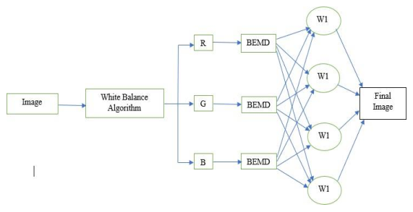
Fig.4.1. Block Diagram of White Balanced BEMD
By using this method, the unwanted color cast of the image is removed. And also the contrast of the image is adjusted to its maximum rate.
The color correction has been done through both auto level adjustment and manual adjustment techniques on respectively thirty underwater images taken at 1m, 3m and 5m depth. These techniques will notify the mean, standard deviation and median values of the corrected images as shown in Figure 2.

V. RESULTS
The Fig.6 shows the underwater image suffers from poor quality due scattering effects, illumination conditions etc. is taken as the input image.
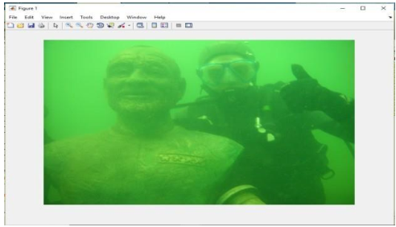
Fig 5.1.Input Raw image
The fig.7 shows the gray scaled version of input raw image.
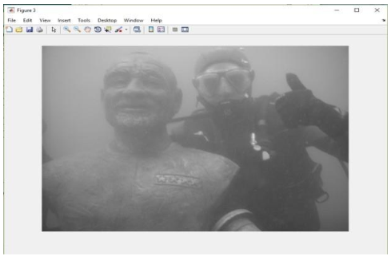
Fig.5.2. Grayscale Image
Fig. 8. Shows the image after removing the unwanted color casts which occurred due to scattering effects of light underwater.
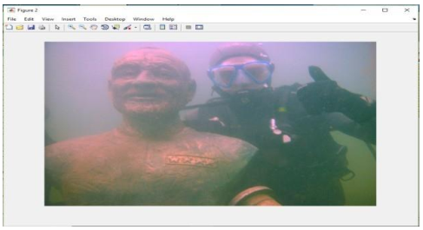
Fig.5.3.White Balanced Image
Fig.9. shows the improved quality image after applying the BEMD technique.
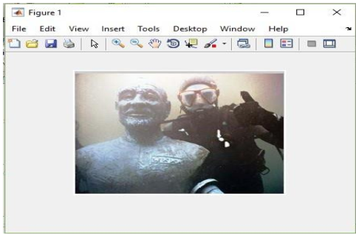
Fig.5.4. Image after BEMD
Table:1 Comparison of Histogram Equalization and BEMD techniques
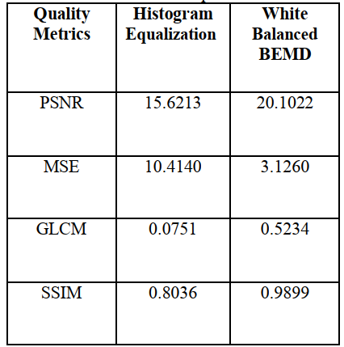

Results by proposed work
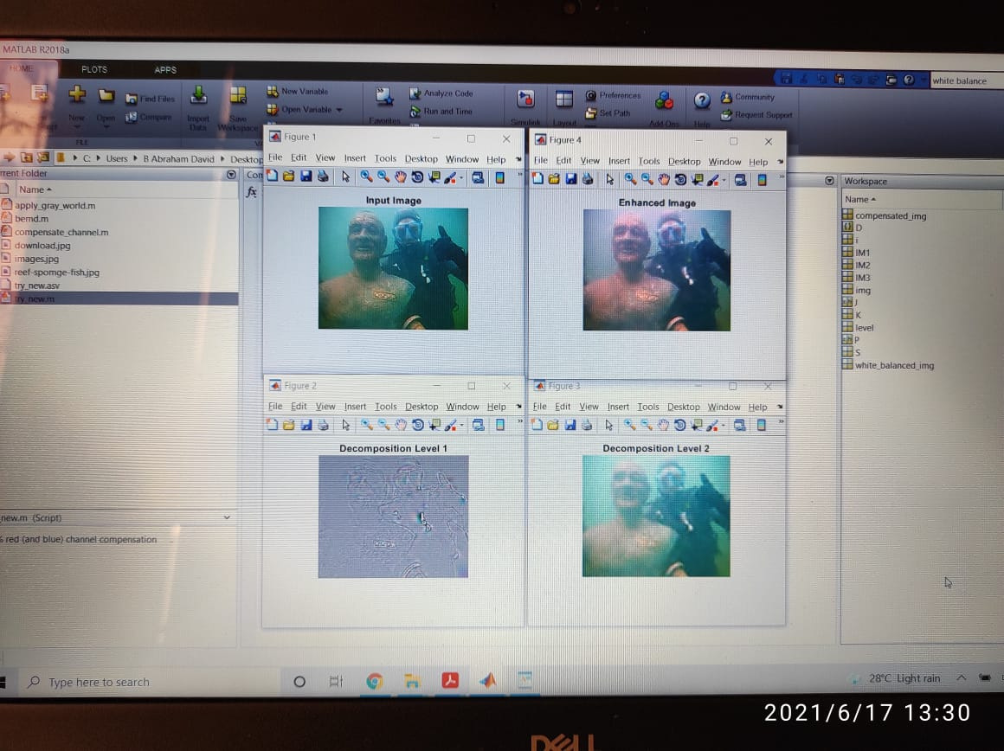

Fig. 5.5 Proposed Method : Decomposition Levels and Enhanced Image

VI. CONCLUSIONS
In the field of image processing, there are several novel techniques are proposed to enhance the visual quality of underwater images. Existing techniques improves the deep water images to a large extent. But all these methods suffer with some poor-quality metrics. A good quality image will have high PSNR, high GLCM and low MSE. Based on these characteristics the proposed method and the conventional method are compared. The results shown that among both the techniques, White Balanced BEMD gives the better enhancement of quality parameters for underwater images.

REFERENCES
[1] Padmavathi, G., et al. "Comparison of filters used for underwater image preprocessing." International Journal of Computer Science and Network Security10.1 (2010): 58-65.
[2] Balvant singh, Ravi shankar mishra, Puran gour, “Analysis of contrast enhancement techniques for underwater image” International journal - of computer technology and electronics engineering (IJCTEE) Volume 1 , issue 2, pp: 190-195
[3] Ritu singh, Dr. Mantosh Biswas, “Adaptive histogram equalization based fusion Technique for hazy underwater image enhancement” IEEE international conference on computational intelligence and computing research, 2016, pp: 1-5
[4] Sonam Bharal, “Review of underwater image enhancement techniques”, International Research Journal of Engineering and Technology (IRJET), and Volume: 02 Issue: 03, June-2015, pp: 340-344.
[5] Sudhansu Mallik, Salman S. Khan, Umesh C. Pati, “Visual Enhancement of Underwater Image by White-Balanced EMD”, 8th International Conference on Computing, Communication and Networking Technologies (ICCCNT) -2017, pp: 1-6.
[6] N. E. Huang et. al, “The empirical mode decomposition and the hilbert spectrum for nonlinear and non-stationary time series analysis,” in proceedings of the Royal Society of London A: Mathematical, Physical and Engineering Sciences, vol. 454, no. 1971. The Royal Society, 1998, pp. 903–995.
[7] Jin Chen et.al “Using Empirical mode decomposition to process marine magneto telluric data,” in Geophysical Journal International, vol. 190,Issue 1,July 2012,pg:293-309.
8. Sowmyashree M. S., Sukrita K. Bekal, R. Sneha, and N. Priyanka. "A Survey on the various underwater image enhancement techniques." International Journal of Engineering Science Invention, 2014.
9. Aysun Tas_yapı Celebi and Sarp Erturk. “Visual enhancement of underwater images using Empirical Mode Decomposition” Elsevier , 2011.
10. Adrian Galdran, David Pardo, Artzai Picón and Aitor Alvarez-Gila” Automatic Red-Channel underwater image restoration” Elsevier, 2014.
11. Neethu M. Sasi and V. K. Jayasree. “ Contrast Limited Adaptive Histogram Equalization for Qualitative Enhancement of Myocardial Perfusion Images” Scientific research, 2013.
12. Dr.G.Padmavathi, Dr.P. Subashini, Mr.M.Muthu Kumar and Suresh Kumar Thakur. “Comparison of Filters used for Underwater Image Pre-Processing” IJCSNS , 2010. 13. Balvant Singh , Ravi Shankar Mishra , Puran Gour. “Analysis of Contrast Enhancement Techniques For Underwater Image” IJCTEE, 2012. 14. Kashif Iqbal, Rosalina Abdul Salam, Azam Osman and Abdullah Zawawi Talib. “Underwater Image Enhancement Using an Integrated Colour Model” IJCS, 2007. 15. John Y. Chiang and Ying-Ching Chen. “Underwater Image Enhancement by Wavelength Compensation and Dehazing” IEEE , 2012. 16. Rafael Garcia, Tudor Nicosevici and Xevi Cufí. “On the Way to Solve Lighting Problems in Underwater Imaging” IEEE, 2002.

Appendix
MATLAB
What Is MATLAB?
MATLAB® is a excessive-performance language for technical computing. It integrates computation, visualization, and programming in an easy-to-use environment wherein issues and answers are expressed in familiar mathematical notation. Typical uses encompass
Typical makes use of MATLAB:
- Math and computation
- Algorithm development
- Data acquisition
- Modeling, simulation, and prototyping
- Data evaluation, exploration, and visualization
- Scientific and engineering pictures
- Application improvement, along with graphical consumer interface constructing.
A.1 Introduction
MATLAB is a immoderate-overall performance language for technical computing. It integrates computation, visualization, and programming in an clean-to-use surroundings wherein troubles and answers are expressed in acquainted mathematical notation. MATLAB stands for matrix laboratory, and become written first off to offer smooth get entry to to matrix software application advanced by using LINPACK (linear system bundle) and EISPACK (Eigen system package deal deal deal) responsibilities.
MATLAB is consequently constructed on a basis of sophisticated matrix software program application in which the important element is array that does not require pre dimensioning which to resolve many technical computing issues, especially people with matrix and vector formulations, in a fragment of time. MATLAB talents a own family of programs specific answers referred to as toolboxes. Very important to most customers of MATLAB, toolboxes permit analyzing and utilizing specialised era. These are complete collections of MATLAB features (M-documents) that growth the MATLAB environment to remedy unique commands of problems. Areas in which toolboxes are available embody sign processing, manipulate device, neural networks, fuzzy appropriate judgment, wavelets, simulation and plenty of others.
Typical uses of MATLAB encompass: Math and computation, Algorithm improvement, Data acquisition, Modeling, simulation, prototyping, Data evaluation, exploration, visualization, Scientific and engineering pics, Application development, along with graphical character interface constructing. Boom the MATLAB environment to remedy unique commands of problems. Areas wherein toolboxes are to be had embody signal processing, control device, neural networks, fuzzy appropriate judgment, wavelets, simulation and lots of others.
Typical uses of MATLAB include: Math and computation, Algorithm improvement, Data acquisition, Modeling, simulation, prototyping, Data analysis, exploration, visualization, Scientific and engineering photos, Application development, along side graphical character interface constructing.
A.2 Basic Building Blocks of MATLAB
The fundamental building block of MATLAB is MATRIX. The essential information type is the array. Vectors, scalars, real matrices and complicated matrix are dealt with as particular magnificence of this fundamental information kind. The built in functions are optimized for vector operations. No size statements are required for vectors or arrays.
A.2.1 MATLAB Window
The MATLAB works based totally on five windows: Command window, Workspace window, Current directory window, Command history window, Editor Window, Graphics window and Online-help window.

A.2.1.1 Command Window
The command window is in which the person sorts MATLAB instructions and expressions on the spark off (>>) and in which the output of those commands is displayed. It is opened when the utility program is released. All instructions inclusive of user-written applications are typed in this window at MATLAB activate for execution.
A.2.1.2 Work Space Window
MATLAB defines the workspace as the set of variables that the person creates in a piece consultation. The workspace browser indicates these variables and a few records about them. Double clicking on a variable inside the workspace browser launches the Array Editor, which can be used to gain facts.

A.2.1.Three Current Directory Window
The present day Directory tab suggests the contents of the present day listing, whose route is hooked up inside the present day listing window. For example, within the domestic windows working tool the path is probably as follows: C:MATLABWork, indicating that directory “paintings” is a subdirectory of the precept list “MATLAB”; it's far mounted in pressure C. Clicking at the arrow in the contemporary listing window shows a listing of currently used paths. MATLAB uses a are in search of for route to discover M-files and different MATLAB related documents. Any document run in MATLAB need to live inside the modern listing or in a list that is on trying to find path.
A.2.1.Four Command History Window
The Command History Window consists of a file of the instructions someone has entered within the command window, which includes each modern and previous MATLAB periods. Previously entered MATLAB instructions may be selected and re-accomplished from the command records window through right clicking on a command or collection of commands. This is beneficial to pick out various alternatives further to executing the instructions and is useful characteristic while experimenting with numerous commands in a piece consultation.
A.2.1.5 Editor Window
The MATLAB editor is every a text editor specialized for growing M-documents and a graphical MATLAB debugger. The editor can seem in a window through the use of itself, or it may be a sub window inside the desktop. In this window you can clearly write, edit, create and preserve applications in documents called M-files.
MATLAB editor window has numerous pull-down menus for responsibilities collectively with saving, viewing, and debugging documents. Because it performs a few smooth assessments and additionally makes use of shade to differentiate among severa factors of code, this newsletter editor is recommended because the device of desire for writing and improving M-functions.
A.2.1.6 Graphics or Figure Window
The output of all photo instructions typed inside the command window is seen in this window.

A.2.1.7 Online Help Window
MATLAB presents online assist for all it’s constructed in features and programming language constructs. The primary manner to get help on-line is to apply the MATLAB assist browser, opened as a separate window each with the useful resource of clicking on the question mark image (?) at the desktop toolbar, or with the aid of typing help browser at the activate inside the command window. The assist Browser is a web browser blanketed into the MATLAB computing tool that shows a Hypertext Markup Language (HTML) documents. The Help Browser includes planes, the assist navigator pane, used to find out statistics, and the display pane, used to view the statistics. Self-explanatory tabs other than navigator pane are used to carry out a are seeking.
A.3 MATLAB Files
MATLAB has 3 varieties of files for storing facts. They are: M-documents and MAT-files.
A.Three.1 M-Files
These are widespread ASCII text record with ‘m’ extension to the document call and growing own matrices using M-files, which are text documents containing MATLAB code. MATLAB editor or any other text editor is used to create a file containing the same statements which are typed at the MATLAB command line and save the record underneath a call that leads to .M. There are sorts of M-documents:
1. Script Files
It is an M-file with a hard and fast of MATLAB commands in it and is achieved by way of typing call of record on the command line. These documents paintings on worldwide variables presently found in that surroundings.
2. Function Files
A characteristic report is also an M-file besides that the variables in a feature record are all local. This type of files starts with a characteristic definition line.
A.3.2 MAT-Files
These are binary information documents with .Mat extension to the record which can be created through MATLAB when the records is saved. The information written in a unique format that only MATLAB can examine. These are located into MATLAB with ‘load’ command.
A.4 The MATLAB System:
The MATLAB machine consists of five important components:
A.4.1 Development Environment:
This is the set of tools and centers that assist you use MATLAB functions and files. Many of those gear are graphical person interfaces. It consists of the MATLAB computer and Command Window, a command history, an editor and debugger, and browsers for viewing assist, the workspace, files, and the quest path.
A.4.2 the MATLAB Mathematical Function:
This is a large series of computational algorithms ranging from elementary features like sum, sine, cosine, and complex mathematics, to greater sophisticated features like matrix inverse, matrix eigen values, Bessel functions, and rapid Fourier transforms.
A.4.3 the MATLAB Language:
This is a excessive-stage matrix/array language with manage glide statements, capabilities, statistics systems, input/output, and item-orientated programming features. It lets in both "programming in the small" to rapidly create quick and dirty throw-away packages, and "programming within the massive" to create complete big and complicated software applications.
A.4.Four Graphics:
MATLAB has large centers for displaying vectors and matrices as graphs, as well as annotating and printing these graphs. It consists of high-degree features for two-dimensional and 3-dimensional statistics visualization, picture processing, animation, and presentation pics. It also includes low-level functions that let you fully customize the appearance of photographs as well as to build complete graphical consumer interfaces to your MATLAB packages.
A.4.5 the MATLAB Application Program Interface (API):
This is a library that allows you to put in writing C and FORTRAN packages that have interaction with MATLAB. It consists of centers for calling exercises from MATLAB (dynamic linking), calling MATLAB as a computational engine, and for reading and writing MAT-files.
Demo demonstrates what is possible in Mat lab
Who lists all of the variables in your Mat lab workspace?
Whose list the variables and describes their matrix size
clear erases variables and functions from memory
clear x erases the matrix 'x' from your workspace
close by itself, closes the current figure window
figure creates an empty figure window
hold on holds the current plot and all axis properties so that subsequent graphing
commands add to the existing graph
hold off sets the next plot property of the current axes to "replace"
findfind indices of nonzero elements e.g.:
d = find(x>100) returns the indices of the vector x that are greater than 100
break terminate execution of m-file or WHILE or FOR loop
A.6 SOME BASIC PLOT COMMANDS:
Kinds of plots:
plot(x,y) creates a Cartesian plot of the vectors x & y
plot(y) creates a plot of y vs. The numerical values of the factors inside the y-vector
semilogx(x,y) plots log(x) vs y
semilogy(x,y) plots x vs log(y)
loglog(x,y) plots log(x) vs log(y)
polar(theta,r) creates a polar plot of the vectors r & theta wherein theta is in radians
bar(x) creates a bar graph of the vector x. (Note also the command stairs(x))
bar(x, y) creates a bar-graph of the elements of the vector y, finding the bars
consistent with the vector factors of 'x'
Plot description:
grid creates a grid at the images plot
A.7 ALGEBRIC OPERATIONS IN MATLAB:
Scalar Calculations:
+ Addition
- Subtraction
* Multiplication
/ Right department (a/b approach a ÷ b)
left division (ab manner b ÷ a)
^ Exponentiation
For instance three*four carried out in 'matlab' gives ans=12
4/five offers ans=0.Eight
Array products: Recall that addition and subtraction of matrices involved addition or subtraction of the character factors of the matrices. Sometimes it's far favored to definitely multiply or divide every element of an matrix by way of the corresponding element of any other matrix 'array operations”.
Array or detail-by way of-element operations are accomplished when the operator is preceded via a '.' (Period):
a .* b multiplies each detail of a by using the respective element of b
a ./ b divides each element of a by using the respective detail of b
a . B divides every detail of b by using the respective detail of a
a .^ b raise each detail of a with the aid of the respective b element
A.8 MATLAB WORKING ENVIRONMENT:
A.8.1 MATLAB DESKTOP
Matlab Desktop is the principle Matlab software program window. The laptop includes 5 sub domestic home windows, the command window, the workspace browser, the current list window, the command history window, and one or greater determine home windows, which can be tested most effective when the individual displays a photo.
The command window is in which the person kinds MATLAB instructions and expressions at the spark off (>>) and wherein the output of those commands is displayed. MATLAB defines the workspace as the set of variables that the patron creates in a work session. The cutting-edge Directory tab above the workspace tab suggests the contents of the present day listing, whose path is shown in the current list window.
For example, in the domestic home windows running device the course is probably as follows: C:MATLABWork, indicating that listing “art work” is a subdirectory of the primary listing “MATLAB”; WHICH IS INSTALLED IN DRIVE C. Clicking at the arrow within the modern list window indicates a list of these days used paths. Clicking at the button to the proper of the window permits the user to change the modern-day listing. MATLAB uses a are seeking for route to locate M-files and other MATLAB related files, which is probably arrange in directories within the laptop report system. Any document run in MATLAB want to are living inside the cutting-edge list or in a list this is on are seeking route. By default, the documents supplied with MATLAB and math works toolboxes are protected within the are looking for direction.
The simplest manner to look which directories are soon the quest path, or to characteristic or alter a seek direction, is to choose set path from the File menu the laptop, after which use the set direction communication box. It is right exercise to feature any normally used directories to the search course to avoid time and again having the change the cutting-edge list.
The Command History Window includes a file of the commands a consumer has entered in the command window, along with every modern and previous MATLAB periods. Previously entered MATLAB commands can be determined on and re-accomplished from the command history window by the use of right clicking on a command or sequence of commands.
This motion launches a menu from which to choose out numerous options further to executing the instructions. This is useful to choose out severa options in addition to executing the instructions. This is a beneficial feature at the same time as experimenting with various commands in a piece consultation.
A.8.2 Using the MATLAB Editor to create M-File:
The MATLAB editor is each a textual content editor specialized for growing M-files and a graphical MATLAB debugger. The editor can appear in a window via itself, or it could be a sub window within the laptop. M-files are denoted by using the usage of the extension .M, as in pixelThe MATLAB editor window has numerous pull-down menus for tasks together with saving, viewing, and debugging files. Because it plays a few simple assessments and also makes use of coloration to distinguish among severa elements of code, this newsletter editor is recommended due to the fact the tool of desire for writing and modifying M-abilties.
To open the editor , kind edit at the prompt opens the M-record filename.M in an editor window, equipped for enhancing. As stated earlier, the report must be inside the modern-day listing, or in a listing within the are looking for route.
A.8.Three Getting Help:
The most critical manner to get assist online is to use the MATLAB help browser, opened as a separate window either through clicking on the question mark symbol (?) at the computer toolbar, or through typing help browser on the set off in the command window. The help Browser is an internet browser incorporated into the MATLAB laptop that presentations a Hypertext Markup Language(HTML) files. The Help Browser includes two panes, the help navigator pane, used to find records, and the display pane, used to view the statistics. Self-explanatory tabs apart from navigator pane are used to carry out a search.

DIGITAL IMAGE PROCESSING

Analysis and manipulation on image to get some feature or to improve the quality of that image is called digital image processing (DIP).
E.g. detection and tracking, Removal of noise from blur image.
3.1Components of Digital Image Processing (DIP)

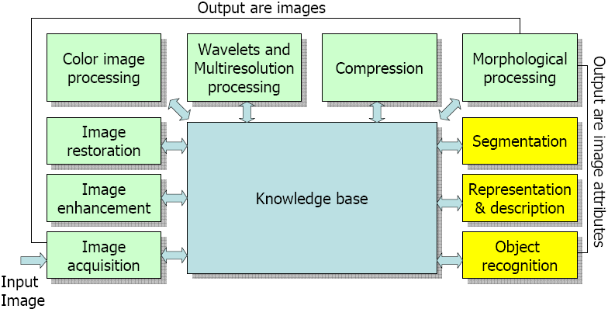

Fig.: Components of Digital Image Processing (DIP)

3.1.1. Image Acquisition

The first stage of any vision system is the image acquisition stage. Image acquisition is nothing but capturing of an image using some reflecting phenomenon. After the image has been obtained, various methods of processing can be applied to the image to perform the many different vision tasks required today.
3.1.2. Image Enhancement
The principal objective of image enhancement is to process a given image so that the result is more suitable than the original image for a specific application. It accentuates or sharpens image features such as edges, boundaries, or contrast to make a graphic display more helpful for display and analysis. The enhancement doesn't increase the inherent information content of the data, but it increases the dynamic range of the chosen features so that they can be detected easily. The greatest difficulty in image enhancement is quantifying the criterion for enhancement and therefore, a large number of image enhancement techniques are empirical and require interactive procedures to obtain satisfactory results.Image enhancement methods can be based on either spatial or frequency domain techniques.
3.1.3. Image Restoration
The purpose of image restoration is to "compensate for" or "undo" defects which degrade an image. Degradation comes in many forms such as motion blur, noise, and camera miss focus. In cases like motion blur, it is possible to come up with a very good estimate of the actual blurring function and "undo" the blur to restore the original image. In cases where the image is corrupted by noise, the best we may hope to do is to compensate for the degradation it caused. In this project, we will introduce and implement several of the methods used in the image processing world to restore images.
3.1.4. Color Image Processing
The human visual system can distinguish hundreds of thousands of different colour shades and intensities, but only around 100 shades of grey. Therefore, in an image, a great deal of extra information may be contained in the colour, and this extra information can then be used to simplify image analysis, e.g. object identification and extraction based on colour. Three independent quantities are used to describe any particular color. The hue is determined by the dominant wavelength. Visible colours occur between about 400nm (violet) and 700nm (red) on the electromagnetic spectrum.

3.1.5. Wavelets and Multiresolution Processing
Unlike the Fourier transform, which decomposes a signal to a sum of sinusoids, the wavelet transform decomposes a signal (image) to small waves of varying frequency and limited duration. The advantage is that we also know when (where) the frequencies appear. We will examine wavelets from a multiresolution point of view and begin with an overview of imaging techniques involved in multiresolution theory.
In numerical analysis and functional analysis, a discrete wavelet transform (DWT) is any wavelet transform for which the wavelets are discretely sampled. As with other wavelet transforms, a key advantage it has over Fourier transforms is temporal resolution: it captures both frequency and location information (location in time).
3.1.6. Image Compression
There are two categories of compression techniques used with digital graphics, lossy and lossless. Whilst each uses different techniques to compress files, both have the same aim. To look for duplicate data in the graphic and use a much more compact data representation. Lossy and Lossless each have various methods which are used by different file formats and achieve different results. Therefore not all lossy or lossless formats will use the same methods. It is beyond the scope of this Unit to look at these methods in detail so you will not be assessed on them.
The Unit entitled Digital Imaging: Bitmaps covers compression methods in more detail. If you are a bit unclear about this, the following may help:
Lossy compression methods include DCT (Discreet Cosine Transform), Vector Quantization and Huffman coding.
Lossless compression methods include RLE (Run Length Encoding), string-table compression, LZW (Lempel Ziff Welch) and zlib.

3.1.7. Morphological Image Processing
Morphological image processing is a collection of non-linear operations related to the shape or morphology of features in an image. According to Wikipedia, morphological operations rely only on the relative ordering of pixel values, not on their numerical values, and therefore are especially suited to the processing of binary images. Morphological operations can also be applied to grayscale images such that their light transfer functions are unknown and therefore their absolute pixel values are of no or minor interest. Morphological techniques probe an image with a small shape or template called a structuring element. The structuring element is positioned at all possible locations in the image and it is compared with the corresponding neighborhood of pixels.
It includes following four operations:
1. Dilation
2. Erosion
3. Opening
4. Closing

3.1.8. Image Segmentation
In computer vision, image segmentation is the process of partitioning a digital image into multiple segments (sets of pixels, also known as super pixels). The goal of segmentation is to simplify and/or change the representation of an image into something that is more meaningful and easier to analyze. Image segmentation is typically used to locate objects and boundaries (lines, curves, etc.) in images. More precisely, image segmentation is the process of assigning a label to every pixel in an image such that pixels with the same label share certain characteristics.
The result of image segmentation is a set of segments that collectively cover the entire image, or a set of contours extracted from the image (see edge detection). Each of the pixels in a region is similar with respect to some characteristic or computed property, such as color, intensity, or texture. Adjacent regions are significantly different with respect to the same characteristic(s). When applied to a stack of images, typical in medical imaging, the resulting contours after image segmentation can be used to create 3D reconstructions with the help of interpolation algorithms like marching cubes.
3.1.9. Image Representation, Object Recognition
Object recognition is a process for identifying a specific object in a digital image or video. Object recognition algorithms rely on matching, learning, or pattern recognition algorithms using appearance-based or feature-based techniques. After an image is segmented into regions; the resulting aggregate of segmented pixels is represented & described for further computer processing. Representing region involves two choices: in terms of its external characteristics (boundary) in terms of its internal characteristics (pixels comprising the region).Above scheme is only part of task of making data useful to computer. Next task is to describe the region based on representation. Ex. A region may be represented by its boundary & its boundary is described by features such as its length, the orientation of straight line joining its extreme points & number of concavities in the boundary.

